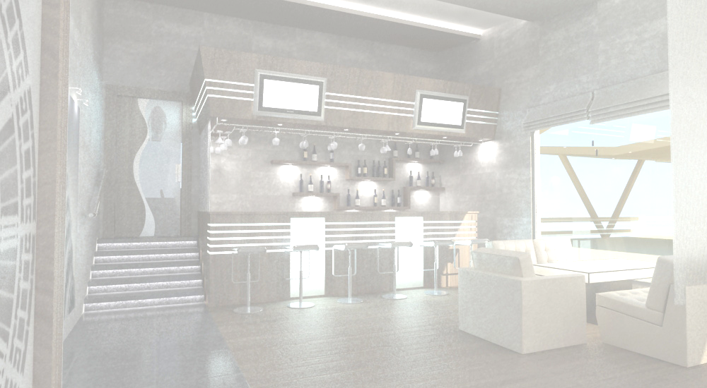
garnirebi
Side Dishes
kartofili "fri" |  |  |  |  |  |  |  |  |  |  |  |  |  | 4.00 | lari
French Fries |  |  |  |  |  |  |  |  |  |  |  |  |  | 4.00 | GEL
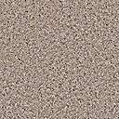kartofili xaxvSi Semwvari |  |  |  |  |  |  |  |  |  |  |  |  |  | 3.50 | lari
Potato fried in onion |  |  |  |  |  |  |  |  |  |  |  |  |  | 3.50 | GEL
RumelSi Semwvari mundiriani kartofili |  |  |  |  |  |  |  |  |  |  |  |  |  | 3.00 | lari
Backed Potato |  |  |  |  |  |  |  |  |  |  |  |  |  | 3.00 | GEL
kartofilis piure |  |  |  |  |  |  |  |  |  |  |  |  |  | 3.00 | lari
Mashed potatoes, |  |  |  |  |  |  |  |  |  |  |  |  |  | 3.00 | GEL
brinji moxarSuli |  |  |  |  |  |  |  |  |  |  |  |  |  | 3.00 | lari
Steamed Rice |  |  |  |  |  |  |  |  |  |  |  |  |  | 3.00 | GEL
brinji bostneuliT |  |  |  |  |  |  |  |  |  |  |  |  |  | 4.00 | lari
Rice With Vegetable |  |  |  |  |  |  |  |  |  |  |  |  |  | 4.00 | GEL
moTuSuli bostneuli |  |  |  |  |  |  |  |  |  |  |  |  |  | 4.50 | lari
Pen Fried Vegetable |  |  |  |  |  |  |  |  |  |  |  |  |  | 4.50 | GEL
brokoli moxarSuli |  |  |  |  |  |  |  |  |  |  |  |  |  | 4.50 | lari
Steamed Vegetables |  |  |  |  |  |  |  |  |  |  |  |  |  | 4.50 | GEL
bostneuli grilze Semwvari: badrijani, qama soko, bulgaruli wiwaka |  |  |  |  |  |  |  |  |  |  |  |  |  | 6.50 | lari
Griled Vegetables: Eggplant, Mushroom,Bulgar pepper |  |  |  |  |  |  |  |  |  |  |  |  |  | 6.50 | GEL
pasta
Pasta
spageti karbonara: pasta spageti, bekoni, naRebi,kvercxi, parmazani |  |  |  |  |  |  |  |  |  |  |  |  |  | 14.00 | lari
Spaghetti cabonara: Pasta Spaghetti, Bacon, Cream, Egg, Parmesan Cheese |  |  |  |  |  |  |  |  |  |  |  |  |  | 14.00 | GEL
pene arabiata: pasta pene, pomidvris sousi, bazeliki |  |  |  |  |  |  |  |  |  |  |  |  |  | 14.00 | lari
Penne pasta: Pasta Penne, Tomato Sauce, Basilica |  |  |  |  |  |  |  |  |  |  |  |  |  | 14.00 | GEL
kvadro formajo: pasta spageti, naRebi, mocarela, parmezani, Cederi, ementali |  |  |  |  |  |  |  |  |  |  |  |  |  | 18.00 | lari
Quadro Format: Pasta Spaghetti, Cream, Mozzarella, Parmesan, Cheddar, Amental |  |  |  |  |  |  |  |  |  |  |  |  |  | 18.00 | GEL
fetuCini bolonezi: pasta fetuCini, sousi bolonezi, baziliki |  |  |  |  |  |  |  |  |  |  |  |  |  | 1500 | lari
Fettuccini Bolognaise: Pasta Fettuccini, Bolognese Sauce, Basilica |  |  |  |  |  |  |  |  |  |  |  |  |  | 1500 | GEL
toliateli fungi: pasta toliateli, qama soko, naRebi, parmezani |  |  |  |  |  |  |  |  |  |  |  |  |  | 14.00 | lari
Tolitely fungi: pasta Toiletry, mushroom, Cream, Parmesan |  |  |  |  |  |  |  |  |  |  |  |  |  | 14.00 | GEL
toliateli: pasta toliateli bolonezi |  |  |  |  |  |  |  |  |  |  |  |  |  | 1500 | lari
Tolitely: pasta Toiletry With Bolognese Sauce |  |  |  |  |  |  |  |  |  |  |  |  |  | 1500 | GEL
pica
Pizza
saerTo yvela picisTvis: pomidvris sousi da mocarela
da Tqveni arCevani:
xaxvi, soko, tkbili wiwaka, Cili, ananasi, simindis marcvlebi, anCousi, “lurji” yveli, qaTami, bekoni, moxarSuli lori, zeTis xili, artiSoki, CaSuSuli ispanaxi, Tinusi
CornerBase pizza with Mozzarella And tomato Sauce
Plus your choice of toppings:
onions, mushrooms, bell pepper, chili,
pineapple, sweet corn, anchovies, blue cheese, chicken, salami, crispy bacon,
cooked ham olives, artichokes, sautéed
spinach, garlic, tuna

 |  |  |  |  |  |  |  |  |  |  |  |  | 24.00 |  | lari
 |  |  |  |  |  |  |  |  |  |  |  |  |  |  | GEL
cxare  spicy |  | vegeterianuli  vegetarian | alkoholuri  Cortains alcohol |  |  |  | 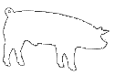  Roris xorci  pork |  |  18:00 saaTamde Till 18:00
visac dietis an alergiis gamo surs icodes sakvebis Semadgenloba, gTxovT mimarToT mimtans
For those with special dietary requirements or allergies, please ask our waiter for assistance
momsaxureoba-15%
Service charge-15%

